Carlisle City Council December 2017
Proposal for Public Space Protection Order
Background Information

Carlisle City Council - Public Space Protection Order
Introduction
Carlisle City Council (the Council) faces quite complex challenges around anti-social behaviour and a number of issues have been raised by the public and businesses that need to be addressed. The Council wants to ensure that it continues to improve the quality of our local environment and green spaces so that everyone can enjoy living, working in and visiting Carlisle. To help us achieve this we want to put measures in place to deter anti-social behaviour whilst continuing to ensure that appropriate support is in place to protect some of the most vulnerable people in our city.
The proposed Public Space Protection Order (PSPO) seeks to replace two types of orders which are already in place: (a Designated Public Place Order (‘DPPO’), and a Dog Control Order). The existing orders place controls on the consumption of alcohol in public spaces and the behaviour of dogs and their owners. The proposed PSPO will keep these controls in place and will place controls on other types of behaviour in addition. A brief description of each type of behaviour which will be controlled is set out in this document.
The proposed PSPO is now at the consultation stage and we are consulting with the public to provide you with the opportunity to tell us what you think of the proposal. There are a number of ways you can express your views and these are set out in the “What happens next?” section at the end of this document.
What is a Public Space Protection Order?
Public Space Protection Orders (PSPO) were created by the Anti-social Behaviour, Crime and Policing Act 2014. PSPOs provide wide ranging and flexible powers to a local authority to help tackle anti-social and nuisance behaviour. PSPOs do not focus on individuals or properties; rather they focus on the identified problem behaviour in a specific location and impose restrictions on behaviours that apply to everyone in that locality. Further information can be found on the following links.
http://www.legislation.gov.uk/ukpga/2014/12/part/4/chapter/2/enacted
https://www.gov.uk/government/uploads/system/uploads/attachment_data/file/352562/ASB_Guidance_v8_July2014_final__2_.pdf
Local authorities have the power to implement these orders to help tackle anti-social behaviour. The order works by imposing conditions on the use of that area which can apply to everyone or certain groups of people. A person who is guilty of an offence under this Order shall be liable on summary conviction to a fine not exceeding level 3 on the standard scale. The orders have effect for up to three years and can be extended.

Proposed area to be covered by the PSPO
The proposed PSPO will cover the full Carlisle City Council local authority area as shown on the map below. This area is known as the ‘Restricted Area’.
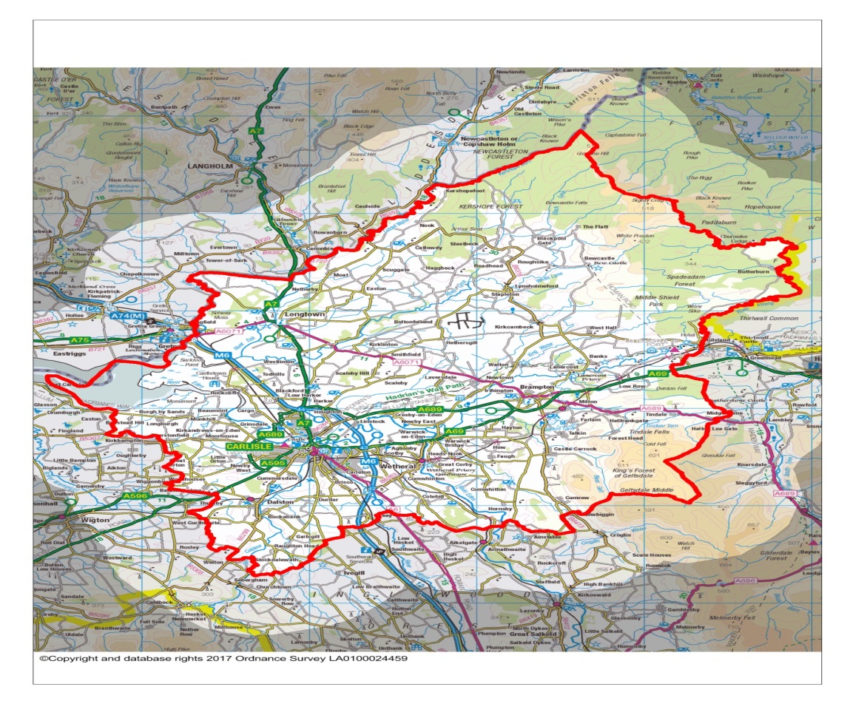
This will allow the greatest flexibility for the authority to deploy measures to tackle anti-social behaviour across the city. The previous orders being replaced such as the Designated Public Place Order and Dog Control orders already cover the majority of the local authority area.
The ‘new’ behaviours to be addressed under the PSPO are:
- Challenging anti-social behaviour by groups or individuals in the city centre public spaces and car parks within the district;
- Smoking, consuming alcohol, drug taking and solvent abuse in play areas; and
- Dogs excluded from enclosed play areas.
As part of the PSPO we are also introducing the requirement for dogs to be kept on their leads in the following areas:

- Carlisle Cemetery and Crematorium;
- Stanwix Cemetery;
- Upperby Cemetery Manor Road; and
- That part of Talkin Tarn Country Park shown on the plan attached to the proposed PSPO.
What will be included in the PSPO for Carlisle?
The PSPO would encompass activities which are currently covered by existing orders under previous legislation together with other activities which are currently not subject to orders. The activities are detailed below:

Designated Public Place Orders (DPPO)
At present there is a DPPO in place which covers the majority of the local authority area and places restrictions on public consumption of alcohol. These restrictions compel any person to surrender alcohol upon instruction by a Police Constable or Police Community Support Officer. However, they can only be used in areas that have experienced alcohol-related disorder or nuisance. These powers are not intended to disrupt peaceful activities such as families having a picnic in a park or on the beach. While police officers have the discretion to require an individual to refrain from drinking regardless of behaviour there is not an intention to challenge an individual consuming alcohol where that individual is not causing a problem. The inclusion of drinking alcohol in a public place within this PSPO would enable authorised officers to continue to take action to tackle alcohol related disorder or nuisance behaviour.

Dog Control Orders
At present there is a Dog Control Order in place which covers the whole of the local authority area.
Dog Control Orders have been in place since 2007, they regulate a number of offences including the control of dogs on leads and fouling of land by dogs. Enforcement action in relation to Dog Control Orders is taken by the Council against persons seen to contravene the Order either by prosecution or by means of a fixed penalty notice. The proposed PSPO would allow the continuation of these enforcement actions.
Exceptions Registered guide and assistance dogs are exempt from the restrictions.

It is proposed that the new PSPO would also include the following activities
Challenging anti-social behaviour by groups or individuals in the City Centre, public spaces and carparks across Carlisle, including:
Behaviour that may be seen as intimidating or threatening to others
Behaviour that could cause offence, distress, annoyance or harassment to others through shouting, swearing, and general anti-social behaviour
Driving or permitting a vehicle to be used in a manner that causes or is likely to cause harassment, alarm, risk or distress to any person
Running or revving of engines (as to cause a nuisance)
Racing motor vehicles or driving motor vehicles around the location at speed
Sounding a horn
Playing loud music
Congregating in a car park for the purposes of socialisation without the express permission of the City Council.
Any variation of the above.

Smoking, consuming alcohol, drug taking and solvent abuse in play areas
Any person smoking any tobacco or tobacco related product, smokeless tobacco product including electronic cigarettes or herbal cigarettes. Any person consuming alcohol and possessing an open vessel(s) and any persons taking drugs and/or solvents and so called 'legal highs' within the boundary of children’s play areas.
Stopping smoking in playgrounds will support the de-normalisation of smoking. If children see their role models smoking they will deem it normal and acceptable. There is a wealth of evidence showing that children that are exposed to seeing smoking by their role models, go on to become smokers.
Cigarette butts are non-biodegradable so remain toxic. This poses a threat to children if ingested and to wildlife. Parks and open spaces have seen an increased use of the public spaces being used for the illegal use of drugs and alcohol related issues, this prohibition will be in play areas only.

It is recognised that there is a small minority of people who contribute to the above issues, having the ability to tackle this type of behaviour will enable our city centre, public spaces and car parks to be enjoyed by those who live, work and visit Carlisle. The police and council officers have raised and tackled a number of anti-social behaviour in these areas and having the ability to manage and control this behaviour is essential. The police will have the ability to deal with minor acts of anti-social behaviour more effectively, saving time and resources.

No dogs allowed in enclosed play areas.
The proposed order would exclude dogs from all outdoor, enclosed children’s play areas within the City of Carlisle to prevent dog mess and dogs from being out of control or frightening children.
The council believes that children should be free to play on the equipment provided in these areas without the fear of treading in or coming in contact with dog faeces or dog urine. Dogs taken in to children’s play areas may also become aggressive if startled. Some children may be frightened of dogs.

What happens next?
We welcome your views on the proposed introduction of the PSPO. There are a number of ways you can tell us your views.
This leaflet gives some detailed background to the proposals. This information can be found online together with the questionnaire at the link shown below.
The Order and Plan showing the extent of the restrictions may be inspected at the Customer Contact Centre, Ground Floor, Civic Centre, Rickergate, Carlisle CA3 8QG between the hours of 9.00 a.m. and 5.00 p.m. Mondays to Thursdays and between 9.00 a.m. and 4.00 p.m. on Fridays up to close of business on Friday 19 January 2018
- Complete an online questionnaire at: www.carlisle.gov.uk/consultations
- Complete a paper questionnaire: copies are available upon request and can be sent to:
Carlisle City Council
Civic Centre
Rickergate
Carlisle
Cumbria
CA3 8QG

Or email: customerservices@carlisle.gov.uk

- Write or email us at the address above (please mark it ‘Public Space Protection Order consultation’).
Completing the above questionnaire, emailing or writing with your views will be taken as you assisting the Council with our consultation process and all views and opinions will be considered.
If you wish to make a formal objection to the making of the intended Public Spaces Protection Order you should make should make representations in writing to Carlisle City Council, Legal Services, Governance Directorate, Civic Centre, Carlisle, CA3 8QG confirming that you want your letter to be considered as a formal objection not later than Friday 19 January 2018
This consultation will close on Friday 19 January 2018.
The Council’s Executive Committee will make the final decision about the Public Space Protection Order. Details of the Executive meeting and subsequent decisions will be published on the Council’s website - www.carlisle.gov.uk
If you need this information in another format or language, please contact us at 01228 817200 or email customerservices@carlisle.gov.uk

Proposed area for Dog on Lead – Talkin Tarn
