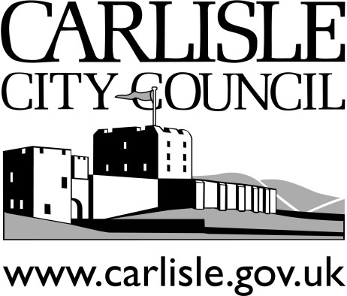

Licensing Act 2003
Responsible Authorities

Where an application is made for a new, or full variation to, a Premises Licence, the original application form must be sent to the Licensing Manager, with copies to the other Responsible Authorities named below:

Licensing Manager Original application form,
Governance Directorate fee, plans etc.
Carlisle City Council
Civic Centre
Carlisle
CA3 8QG

Tel: 01228 817523
Email: licensing@carlisle.gov.uk

Principle Environmental Health Manager Health & Safety
Local Environment Food Safety
Carlisle City Council (Environmental Health)
Civic Centre
Carlisle
CA3 8QG

Tel: 01228 817326
Email: EnvironmentalHealth@carlisle.gov.uk

Development Management Manager Planning Authority
Economic Development
Carlisle City Council
Civic Centre
Carlisle
CA3 8QG

Tel: 01228 817175
Email: dc@carlisle.gov.uk
_________________________________

Cumbria Police Divisional HQ
Police Licensing Officer Chief Officer of Police
Srgt Stuart Campbell (Carlisle City area)
Brunel Way Carlisle
CA1 3NQ
Tel: 101

The Inspector Chief Officer of Police
Cumbria Constabulary (Carlisle Rural area)
Longtown Road
Brampton
Cumbria
CA8 1SJ

Tel: 101

Fire Safety Officer Chief Fire Officer
Cumbria Fire & Rescue Service
Carlisle East
Community Fire Station
Eastern Way
Carlisle
CA1 3RA

Tel: 01228 221689
Email: stuart.graham1@cumbriacc.gov.uk

Business Support Protection of Children from Harm
Performance Unit
Children’s Services
Lower Gaol Yard, The Courts,
Carlisle
CA1 1PU

Tel: 01228 226794
Email: LSCB@cumbria.gov.uk

Trading Standards Weights and Measures
Community Fire Station
Eastern Way
Carlisle
CA1 3RA

Tel: 01539 713594
Trading.standards@cumbria.gov.uk

Health and Safety Executive Health & Safety
2 Victoria Place (only Local Authority and other
Carlisle public buildings)
CA1 1ER
Tel: 01228 539321

Public Health Lead
Cumbria County Council
The Courts
Carlisle
CA3 8NA
Tel: 01228 606060
publichealthenquiries@cumbria.gov.uk

