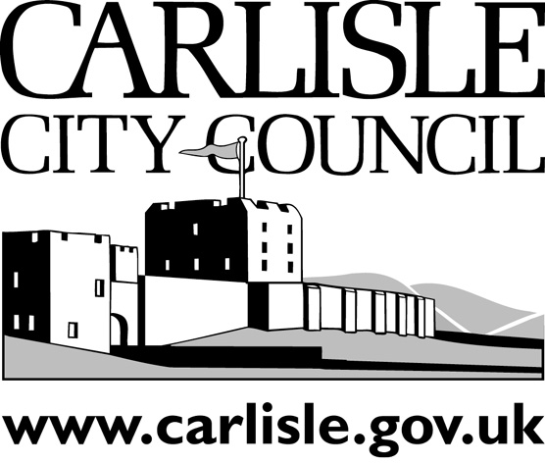

2015 / 2016

**Carlisle City Council Off Street Parking**

**Annual Report**

**Introduction**

The Traffic Management Act 2004 introduced a requirement for Enforcement Authorities to report on their Parking Enforcement Activities on an annual basis.

Carlisle City Council operates a number of ‘Off Street’ car parks most of which are operated as Pay & Display. Enforcement activity is undertaken in these car parks by Carlisle City Council and this report is published to report on those activities.

**Legal provisions**

The Traffic Management Act 2004 (TMA) lays down the requirements under which Civil Parking Enforcement is carried out. These provisions apply to ‘Off Street’ car parks or parking places as well as ‘On Street’ parking places.

The car parks Carlisle City Council operate are subject to a Traffic Regulation Order or TRO

(THE COUNCIL OF THE CITY OF CARLISLE (OFF STREET PARKING PLACES)

(CONSOLIDATION AND MINOR AMENDMENT VARIATION PAY BY TELEPHONE) ORDER 2012)

And other subsequent variation orders made after 2012.

This order and its amendments detail the car park regulations. The order allows Carlisle City Council to issue Penalty Charge Notices (PCNs) for certain contraventions of the order. The issue of these notices and the procedures which follow their issue are laid down by the TMA and regulations made under it.

Patrols and Enforcement activities in the car parks are carried out by Civil Enforcement Officers (CEOs) employed by Carlisle City Council.

**Carlisle City Council Car Parks**

There are 13 Pay & Display Car Parks within the Carlisle district and most are located in the City Centre to service the needs of shoppers, visitors, commuters, workers, recreational and leisure facility users.

Carlisle City Council also operate four Disc controlled Car Parks, one permit holders only car park, five free car parks, two loading area and one public service vehicle area.

**Enforcement**

Carlisle City Council employs two Civil Enforcement Officers (CEOs) FTE 1.4 to patrol and enforce off street parking matters. . The CEOs form part of the Neighbourhood Enforcement team within the Local Environment directorate.

The CEOs are all trained to nationally recognised standards. It is their role to ensure parking compliance is met and also help to ensure any defects or issues affecting the car parks are reported and rectified.

**It is the aim of Carlisle City Council to increase parking compliance and deliver transparent, fair and consistent parking enforcement.**

**Penalty Charge Notices**

A Penalty Charge Notice (PCN) will be issued to a vehicle when a CEO believes the TRO has been contravened. The levels of PCN charges are set by central government; the City Council has adopted a charge currently of £50 for a lower level contravention and £70 for a higher level contravention. If the charge is paid within 14 days a 50% reduction will apply.

Once a PCN has been issued, the driver may submit a challenge. This is known as an informal challenge or representation. The challenge will be considered based on the evidence provided and a decision to either accept or reject the challenge will be made by the Council.

When a challenge is made and rejected, or no payment is received, the owner of the vehicle will be sent a Notice to Owner (NtO). This is the driver’s opportunity to make ‘Formal Representation’ where Consideration of these representations is carried out by the Council.

Should the representations be rejected, the driver has an opportunity to appeal the decision at the Traffic Penalty Tribunal (TPT). The case will be heard by an independent adjudicator and the outcome of this hearing is final, the decision is binding on both the council and the motorist.

**Professional Bodies**

Carlisle City Council is a member of the British Parking Association (BPA) and PATROL. The BPA is the UK’s professional body for the parking industry and PATROL is the joint committee of England and Wales for the civil enforcement of Parking and Traffic Regulations Outside London (PATROL).

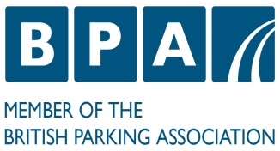 

**Off Street Parking 2015/2016 Statistics**

|  |  |
| --- | --- |
| **Total PCNs Issued** | **3001** |
| **Higher Level PCNs Issued** | **409** |
| **Lower Level PCNs Issued** | **2,592** |
| **Paid at Discount** | **2,042** |
| **Paid at Full (or above)** | **266** |
| **Number of PCNs Paid** | **2,308** |
| **PCNs against which an informal or formal representation was made** | **983** |
| **PCNs Cancelled as a result of an informal or formal representation** | **425** |
| **PCNs written off or cancelled for other reasons** | **127** |
| **Number of appeals at the Traffic Penalty Tribunal** | **5** |
| **Number of appeals allowed** | **1** |
| **Number of appeals dismissed** | **4** |
| **Number of appeals not contested** | **0** |

**Financial Statistics**



The surplus funds raised through the provision of Off-Street parking facilities are used to offset the costs to Carlisle City Council of providing services to the public.

**Richard Chandler**

Car Parks Officer

Carlisle City Council

[carparking@carlisle.gov.uk](mailto:carparking@carlisle.gov.uk)

Published 17.10.16