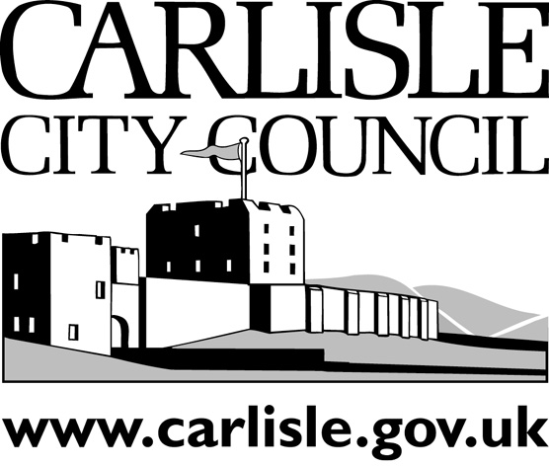
Complaints about Councillors

Privacy Notice

Carlisle City Council is committed to protecting and respecting your privacy in terms of how we collect, use, store and destroy your personal information.

We are the data controller of the personal information we will collect from you and under the General Data Protection Regulation, this privacy notice is designed to provide you with all the information you have a right to be provided with on why we need to collect your personal data and what we will do with it.

Why are we collecting your personal information?
Carlisle City Council needs your information to:
- communicate with you about the process for making and considering complaints
- deal with your complaint under the Council’s arrangements for dealing with Complaints under the Code of Conduct Complaint arrangements.
We may also receive correspondence and information indirectly from third parties such as councillors and town/parish clerks.
The information you submit in the complaint form is the only information we will collect from you.

What allows you to use my information?
When you provide us with your information in order to make an enquiry to make a complaint, we collect and use your information in order to undertake our official duties as a public authority so that we can deal or respond to allegations against members for failure to follow their council’s code of conduct.
The legislation and guidance that allows us to do this includes, but is not limited to:

General Data Protection Regulation Article 6(1)(e) Public Task, whereby the Council will process personal information in the exercise of official authority, under the Localism Act 2011 Chapter 7 on Standards and the Member Complaints Arrangements determined by the Council.

Who will my information be shared with
Under the Code of Conduct Complaint arrangements, the Council may share your information with the following, depending on the progress of your complaint:
- The Monitoring Officer
- Democratic Services Officer
- two Independent Persons and one Parish Representative (if your complaint relates to a Parish matter) who have been appointed by the Council to be consulted on complaints about member conduct
- the Subject Member against whom any allegation is made
- Members (councillors) of
  - Carlisle City Council, including Group Leaders and members of Standards Committee
  - the relevant town/parish council, including the Chairman
- the relevant town/parish clerk
- an Investigator appointed by the Monitoring Officer to conduct an investigation into your complaint and any witnesses and other third parties considered relevant to the investigation
- the Police or other relevant regulatory agency
- the Cumbria Association of Local Councils (CALC)
- the public, where your complaint is investigated and then referred to the Standards Committee for hearing .
- the Information Commissioner and the Local Government Ombudsman

Do I have to provide this information and what will happen if I don't?
This information is required in order for us to deal with your complaint about a Member’s conduct. Anonymous complaints will only be considered if there is independent evidence to substantiate the complaint.
In dealing with your complaint, the Monitoring Officer is unlikely to withhold your identity or the details of your complaint unless they have good reason to grant your request for confidentiality as set out in section C of the Code of Conduct for Members Complaint Form. If you request that your details are kept confidential, the Monitoring Officer, Independent Person and Chairman of the Standards Committee will consider your request alongside the substance of your complaint and will then contact you with the decision.
If your request for confidentiality is not granted, the Monitoring Officer will usually give you the option of withdrawing your complaint.
In certain exceptional circumstances where the matter complained about is very serious, the Monitoring Officer can proceed with an investigation or other action and disclose your information, even if you have expressly asked them not to do so.

How long will you keep your personal information?
Your information will be kept for the period specified in the Council’s data retention schedule i.e. 6 years after the complaint file is closed.

How will my information be stored?
Your information will be stored within the Iken system in Legal Services and a private folder within Democratic Services, with access restricted to the Monitoring Officer and Legal/Democratic Services officers dealing with complaints about Members.

What rights do I have when it comes to my data?
- To be informed
- To access your personal information
- To have inaccurate personal information rectified
- To have personal information erased
- To restrict processing of your personal information
- To obtain and reuse your personal information for your own purpose
- To object to the processing of your personal information
- To not be subject to decisions based solely on automated means, including profiling

Should you be unhappy with the way Carlisle City Council has handled your personal information, we encourage you to let us know so that we can look into this for you and provide a response.

Should you then wish to lodge a complaint with ICO you can contact them at:

Website: https://ico.org.uk/

Address: Information Commissioner’s Officer, Wycliffe House,

Water Lane, Wilmslow, Cheshire, SK9 5AF

Email: Casework@ico.org.uk

Telephone: 0303 123 1113
Carlisle City Council can be contacted at:  Address: Civic Centre, Carlisle,  Cumbria, CA3 8QG  Email: customerservices@carlisle.gov.uk  Telephone: 01228 817200 | Carlisle City Council’s Data Protection Officer can be contacted at:  Address: Civic Centre, Carlisle,  Cumbria, CA3 8QG  Email: dataprotection@carlisle.gov.uk  Telephone: 01228 817200

