Victoria Viaduct Vehicular Diversion
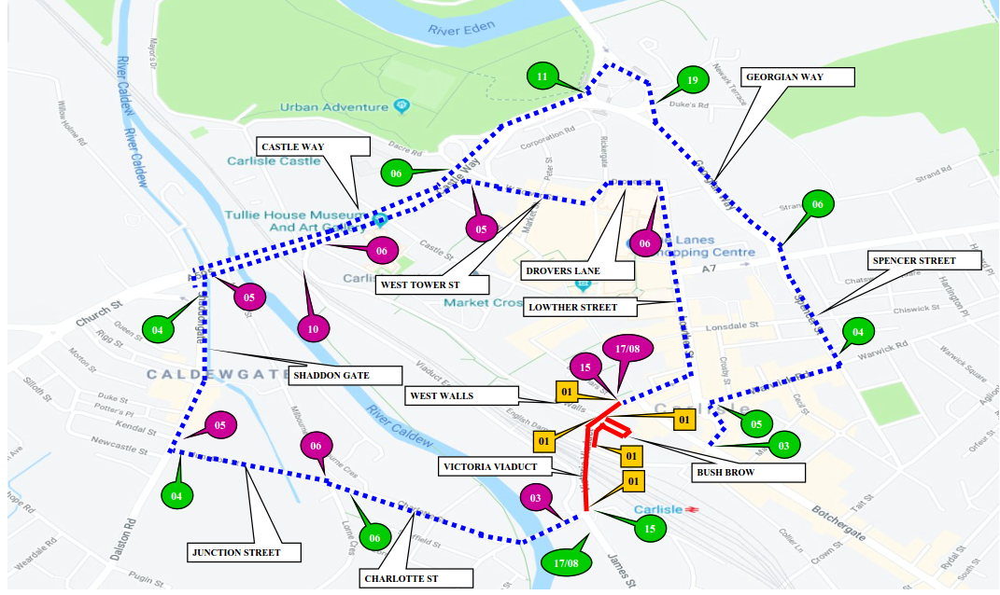

Victoria Viaduct Pedestrian Diversion
