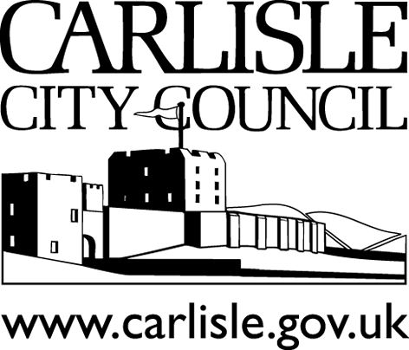Revenues & Benefits Services

Civic Centre, Carlisle, CA3 8QG ● Telephone (01228) 817200
Typetalk 18001 01228 817000 ● www.carlisle.gov.uk

Housing Benefit and Council Tax Reduction – Requesting we look at our decision again.
If you are having difficulty understanding how we have worked out your Housing Benefit or Council Tax Reduction, or would like a more detailed explanation of our decision, please telephone our office for more information on (01228) 817200 or call into our Customer Contact Centre at the Civic Centre, Carlisle CA3 8QG.

For Housing Benefit and Council Tax Reduction decisions you must do this straight away because you are only allowed one month from the date of your award letter to request a written explanation or for us to look at your decision again where you consider it to be wrong / incorrect.

If you still think the decision regarding your Housing Benefit or Council Tax Reduction is wrong / incorrect, or prefer to contact us in writing, please complete this form within one calendar month from the date on your award letter stating why you believe the decision is incorrect.

Please complete the following sections listed below:

1. Your details
Name:

Address:

Benefits Reference:

Daytime Telephone No:

What is the date on the letter which contains the decision that you think is wrong / incorrect.

2. Your Options (see Page 4 for more details)
Do you want to: (please tick one option)
- Request a Statement of Reasons.

- Request a Reconsideration of your Housing Benefit or a Grievance against
your Council Tax Reduction

- Request an Appeal.
3. Reasons for your request
What is the decision you consider to be wrong / incorrect?

Say clearly what you think is wrong / incorrect with the decision. Include any information and evidence that you think we haven’t got.

You have to say why you think the decision is wrong / incorrect. It is not enough to say, “I do not agree with the decision” or “I want to appeal”. The reasons you give should be similar to these examples:
- My working Tax Credit is £35 per week but you have said it is £60 per week.
- I moved into the property on 1 July not 1 August.
- I earn £150 per week but you have shown it as £250 per week.

Please use the space below to say what you want us to explain or why you do not agree with the decision. If you need more space, use another sheet of paper. Please remember to put your name on any extra sheets of paper.

If you are submitting your request more than one month after being notified of the original decision, please say why you have delayed in submitting this form in the space below.

4. About your representative if you have one (for example, your advice worker)

Name:

Relationship to you:

Address:

Their daytime telephone number:

Please sign and date your form:

Your signature:

Date:

Please return this form to:
Housing Benefits Office,
Freepost CE497,
Carlisle City Council,
Civic Centre,
Carlisle, CA3 8QG

Notes

Your Options – further details
- A “Statement of Reasons” is where we will provide you with a detailed explanation, in writing, giving further details of how a decision was made regarding your claim. If you have asked for a statement of reasons, and you subsequently then ask for a reconsideration / grievance / appeal, the calendar month will be extended by the time taken for us to reply to you.

- This is called a “Request for Reconsideration” for Housing Benefit or a “Grievance” for Council Tax Reduction. If you ask us to look at the decision again, we will check your claim again and take account of any more information you have given us. We will consider whether we are able to change our decision and write to you to let you know the outcome.

- If you still disagree with a Housing Benefit decision you will have a further calendar month to Appeal to us in writing with your reasons. If we have still not changed our decision to your advantage, we will then forward your appeal to HM Courts and Tribunals Service. You will be advised of this in writing. (For Council Tax Reduction Appeals, see below).

Council Tax Reduction Appeals

From 1 April 2013 Council Tax Reduction replaced Council Tax Benefit, which has been abolished. As Council Tax Reduction is not a Social Security Benefit, the appeals process is different.

If you think the decision regarding your Council Tax Reduction is wrong, you must write to us, with your reasons. We will respond to your dispute (or ‘Grievance’) within two months of receiving it. If you do not receive a response from us after two months or still disagree with our decision once we have responded, you can make an Appeal directly to the Valuation Tribunal.

You must appeal to the Valuation Tribunal within two months of our final decision and, if we have not responded to you, no later than four months after you initially contacted us with your dispute.

An appeal form can be obtained from www.valuationtribunal.gov.uk and you can submit an appeal online. You can also contact the Valuation Tribunal Service using the details below: -

Valuation Tribunal Service
Hepworth House
2 Trafford Court
Doncaster
Yorkshire
DN1 1PN

Telephone: 0300 123 2035
Facsimile: 01302 321447
E-mail: VTDoncaster@vts.gsi.gov.uk

