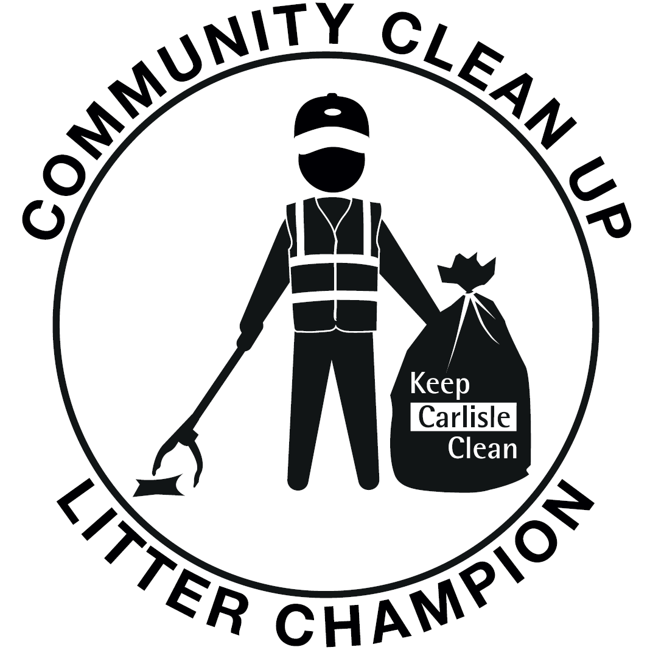

Thank you for joining our litter champion scheme and helping to make a positive difference in your community. By signing up we will provide you with:
- a litter picker, hi-vis vest, gloves, strong black bags for non-recyclable litter and purple bags for recycling glass, cans and plastics (mixed together) all contained within a small wheelie bin for storage.
In return, we ask:
- You keep in contact with our office when you have an event planned, preferably by emailing wasteos@carlisle.gov.uk (or calling 01228 817472) and let us know where the litter picked waste has been left for collection.

- You send us any pictures of the great work you have been doing to wasteos@carlisle.gov.uk

- You fill out our ‘Litter Registration Form’ (attached) and support Carlisle City Council to help improve our local area.

- You follow our health and safety guidelines provided in our do’s and don’ts list and on the risk assessment sheets (attached).

Safety do’s and don’ts list

Do:
- Always wear the hi-vis and gloves provided

- Wear strong boots or shoes

- Wash your hands after litter picking

- Make sure a responsible adult is supervising children taking part in the litter pick

- Carry a mobile phone (if you have one) and always let your family/friends know where you are going and when you are expected home

- Stay on public land and don’t stray off the path

- Continually assess the weather conditions, and other emerging risks, and take timely action to review the litter-picking arrangements for example in the event of severe weather, strong winds, extreme heat, storms etc

Do not:
- Pick up or handle any needles or sharp objects*

- Pick up any dog mess unless taking additional precautions

- Lift anything that is too heavy
- Work on or near any busy or high speed roads / traffic or on blind bends

- Work in severe weather or when visibility is poor or conditions are unsafe

* If you come across any of these items please report them to wasteos@carlisle.gov.uk

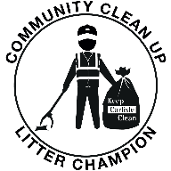
Registration Form
Thank you for volunteering to be a Litter Champion. Please complete this form below (if you are under 18, please ask your parent or carer to countersign and confirm their support for your involvement.
Name
(including group name where relevant:

Address:
Postcode:
Date of Birth (if under 18):
Contact phone number
Email address:

Carlisle City Council will provide you with:
Items | Quantity Required
Litter Pickers
Hi-Vis Vests (Childs, Small, Medium, Large, XL) please specify size
Gloves
Litter picking hoops (to hold bags)
Black bags (for non-recyclable waste)
Purple bags (for glass, cans & plastics only).
Please advise us when you require more bags by emailing wasteos@carlisle.gov.uk

I give my permission for photographs to be used for publicity (please tick)

Please note all items remain the property of Carlisle City Council

Signed……………………………………………................Date……………………………….
PRINT……………………………………………………………………………………………..

CARLISLE CITY COUNCIL SAFETY SHEET | - Litter champions
Name: | Date:
Area:

Covid-19 Guidance – It is important to remember that although many of the Covid restrictions have been lifted, the risks remain the same so please take care to follow all the latest guidance to keep yourself and others safe. Please continue to monitor the guidance and any local restrictions that may come into force. This guidance may be superseded by any subsequent changes in the government legislation. If you have any coronavirus symptoms or have been in contact with anyone who has had symptoms please follow government guidelines, stay at home, and don’t undertake any volunteering activity.

Hazards | Special Precautions or Equipment | Personal Protective Equipment
Aggression/ abuse from members of the public - risk of conflict with member of the public | - Organiser to brief volunteers on how to avoid confrontation – approach members of the public in a non-aggressive way if wishing to challenge their behaviour e.g., littering or dog fouling and do not approach people alone.  - Do not trespass onto private property whilst litter picking.
Extreme Weather - volunteers risk sunstroke, sunburn, dehydration and heat exhaustion due to hot weather  Volunteers risk discomfort from cold weather, wind and rain. | - Volunteers advised to dress appropriately for weather conditions.  - Advise volunteers to take regular breaks and seek shade if necessary.  - Volunteers instructed to avoid areas where debris could come loose, i.e., trees, poorly maintained structures in high winds  - If lightning occurs, workers and volunteers are instructed to cease using litter pickers and stop the event. | - Volunteers advised to wear sun hats and sun cream, re-apply as needed.  - Gloves to be worn on all occasions.  - Volunteers to have access to water and advised to drink plenty.  - Volunteers instructed to wear warm and waterproof clothing, thick socks and sturdy boots  - Gloves
Vehicles on roads and in car parks – volunteers risk injury through contact with moving vehicles | - Children to remain under supervision and in sight of a responsible adult at all times, preferably by a parent or guardian.  - Children not to pick litter from the road but to remain on pavements and paths.  - Prior to event, the organiser to advise volunteers on areas where vehicles maybe present.  - Briefing to include warning on roads, speed limits and any known hazards. Briefing to include warning to always focus when crossing streets and be aware of surroundings at all times  - Be aware of any vehicle, potentially trying to park, maintain vigilance, give warning to others of approaching vehicles  - Volunteers advised that they must not work on roads or on roadside verges.  - Absolutely no litter-picks to take place near railway lines or on bridges. | - Tabards or hi-vis to be worn at all times.
Collection of litter / manual handling -  workers and volunteers risk injuries or back pain from handling heavy loads | - Volunteers instructed not to over-fill bags or try to carry heavy items.  - Volunteers advised to be aware of their own limitations by the event organiser during the briefing and not lift heavy items found during the clean up.  - Volunteers with pre-existing injuries are not to lift bags or heavy items.  - No more than one bag at a time to be carried.  - Under 18s to be supervised by an appropriate adult.  - Only organisers / volunteers trained in safe manual handling procedures offer guidance for safe lifting practices and reducing/removing common hazards and risks (reducing load weight, postural advice when lifting, handling asymmetrical loads, grip, other environmental factors, carry distance, obstacles en-route).  - Volunteers advised on safe manual handling practices.  If too heavy to handle, leave the object in place and report it to the organiser to arrange removal by the council. | - Wheelbarrows to be used to move large/heavy items.  - Assess the weight of items before attempting to lift them.  - Team-lift where safe to do so for heavier or awkward items
Collection of litter – toxic materials / hazardous chemicals | - Volunteers instructed never to approach suspicious looking containers with or without hazard warning badges.  - Any suspicious drums, materials or containers with contents not identifiable to be left untouched and Environment Agency Pollution Hotline to be contacted (Tel 0800 7312453)
Collection of litter – fly-tipped asbestos | - If there is an accumulation of waste which would obviously have been fly-tipped deliberately on site, then this should be left alone and Carlisle City Council to be contacted at wasteos@carlisle.gov.uk
Collection of litter – sharps, syringes and medical waste - volunteers risk injury from sharp items, infection | - Volunteers finding syringes should not touch them, but immediately notify wasteos@carlisle.gov.uk  All work must then cease in this particular area.  - Any accidental piercing by syringe should be immediately treated at a local medical practice or A&E.  - Volunteers instructed never to put sharp objects in bags.  - Broken glass to be collected in bucket/container and disposed of safely at end of the event.  - Volunteers advised not to handle sharps, i.e., needles, syringes, unless competent and trained to do so.  - Volunteers advised to alert organiser if sharps are found and if able, they will arrange proper disposal using sharps kit / by the council. | - All volunteers to use litter pickers and gloves.
Trees, shrubs - trips, cuts & eye pokes | - Be aware of low hanging branches and exposed tree and shrub roots. | - Wear protective eye-wear.
Proximity to water, contact with water | - Volunteers advised to stay away from water’s edge; do not enter the water.
Irritant and dangerous plants - e.g., Giant Hogweed | - Volunteers advised not to touch any potentially irritant and dangerous plants.
Dog fouling / faeces - Toxocara canis | - Do not touch dog faeces.  - Do not use litter-pickers.  - Always wear gloves and use a plastic spade when removing dog faeces.  - If a volunteer steps in dog faeces, clean shoes if possible  - If found warn others in the vicinity  - If touched, thoroughly wash your hands.  - Thoroughly wash any cuts or abrasions as soon as possible, however minor.  - Seek medical attention where appropriate. | - Wear gloves  - Hand washing facilities/hand wipes/hand sanitiser
Slips, trips and falls | - Volunteers advised to wear supportive, slip resistant footwear and no flip flops.  - Take care when negotiating steps  - Volunteers advised to take extra care on overgrown areas, rocky areas, wet/muddy areas or sand dunes.  - Volunteers instructed to take extra care when carrying heavy bags.  - Volunteers advised of any hazardous areas and informed that these are to be avoided.  - If in doubt, don’t carry on if an area looks slippery or dangerous | - Safe footwear
Safeguarding children -  children and vulnerable adults | - All children up to the age of 18 and any vulnerable adults to be accompanied by responsible adult in approved ratios  - No child to be out of sight of a responsible adult  - All staff on site to maintain vigilance where members of the public not participating in the event are using the same public space  - All event volunteers to wear event tabards to allow easy identification  - In the event of an incident, immediately inform the local Police and any other relevant agencies | - Tabards or hi-vis to be worn at all times.
Potential for bacterial infection | - Have clean water available to wash hands.  - All volunteers to wash hands after activities or use antibaceterial gels or wipes.  - All volunteers to wear waterproof gloves.  - All volunteers to wear sturdy footwear. | - Hand washing facilities/hand wipes/hand sanitiser  - Safe footwear

WORK METHOD
- Clean / sanitise hands before and after, at home or nearby w/c facility.
- Frequent use of hand sanitiser is advised and avoid touching face.
- Litter pickers should be sanitised before and after use.
- Ensure that correct procedures are used when moving and lifting rubbish. Use good lifting techniques and be aware of other people around you at all time.
- If you find a needle or sharp object, do not touch it, report it to the Neighbourhood Services Team at Carlisle City Council by email at wasteos@carlisle.gov.uk or 01228 817472 to arrange collection.
- Ensure that you have adequate space around you when using tools.
- Plan system of work before starting.
- Ensure that all tools are used correctly and that any damaged equipment is reported to the group leader/Carlisle City Council.
- Wear robust safety footwear (boots/wellies), which will protect your feet from injury.
- Clothing with long sleeves and full-length trousers are advisable when working near hedgerows or in long grass, etc., where there is a risk of scratches, grazes or insect bites, ticks, etc.
- Wear gloves at all time when working with tools.
- Keep work areas as clear as practicable.
- Ensure that rubbish and tools are not left lying in the path, which can be a trip hazard or left unattended.
- Stop work to let a member of the public past.
- Stay out of the way of vehicles when in use.
- In instances of bad weather wear suitable waterproof/windproof clothing, and in extreme conditions consider whether to go ahead.
- Ensure first aider, first aid kit and mobile phone (check for signal) on site at all time.

ACKNOWLEDGEMENT

I the undersigned have read, understood and will abide by the contents of this Safety Sheet.
I also recognise that the above guidance cannot cover all eventualities and understand that it is important to undertake continuous dynamic risk assessments to reflect changing risks and conditions.

NAME (PRINT) | SIGNATURE | DATE

Please return this sheet to Carlisle City Council, Neighbourhood Services, Civic Centre, Rickergate, Carlisle, CA3 8QG or email wasteos@carlisle.gov.uk , along with the completed registration form. Thank you.

