Recycling Labelling
Packaging labels and recycling symbols appear on lots of everyday items and help us to identify how different types of packaging can be recycled.
This page sets out what the various recycling symbols mean so that you can increase the number of products which you correctly recycle.
Remember that not all packaging will have a recycling label, but this doesn’t mean you can’t recycle it. Follow the recycling and reuse advice if you would like further information on specific materials.

The on-pack recycling label (OPRL)
Look out for these labels which appear on all sorts of packaging – from soft drink cans, to bread bags and plastic toiletry bottles.
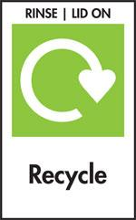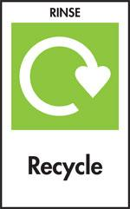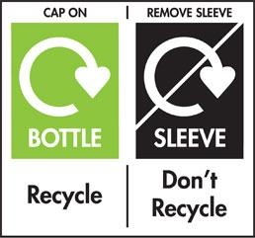

They will tell you whether the packaging is likely to be collected for recycling or if you can take it to your local recycling centre. For instance, you can recycle bread bags and plastic films at many large supermarkets.
However, it is important that you continue to follow advice from your local district council the ‘recycle’ label is applied to packaging collected by 75% or more of local authorities, but not necessarily all.

The Green Dot
This symbol does not necessarily mean that the packaging is recyclable, will be recycled or has been recycled. It is a symbol used on packaging that signifies that the producer has made a financial contribution towards the recovery and recycling of packaging.

You should still check local recycling advice if you are unsure whether something can be recycled.

Mobius Loop
This symbol indicates that a product is capable of being recycled, not that the object has been recycled or accepted in all recycling collection systems. It is therefore important that you check local recycling advice.

Plastic resin codes
This identifies the type of plastic resin used to make the item. Although this doesn’t necessarily indicate whether a product is recyclable, PET (1) and HDPE (2) are frequently recyclable at the kerbside, with your local district council also being able to collect Pots, Tubs and Trays (PE or PP).

Waste electricals
This symbol explains that you should not place the electrical item in general waste. Electrical items can be recycled at the Household Waste Recycling Centres, as well as through take-back schemes at local retailers for batteries and other electrical items.
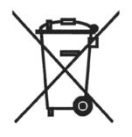

Compostable
Products certified to be industrially compostable may bear the ‘seedling’ logo. Never place compostable plastic into the recycling, it is designed to break down and therefore cannot be recycled and contaminates recyclables plastics.
You can purchase a discounted home composting bin through visiting the following webpage: http://www.recycleforcumbria.org/inthegarden/default.asp.

