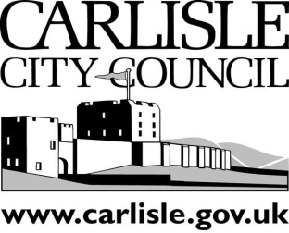
Carlisle City Council

BELAH & KINGMOOR
WARD

COUNCILLORS’ SURGERY

will be held at

Rockcliffe Parish Hall

5.00 p.m. — 7.00 p.m.

on

Thursday, 26th September 2019

Your City Councillors Gareth Ellis and David Morton are holding a Surgery where you can raise any matters causing you concern.

With the imminent Planning Application for homes at Crindledyke, what are your thoughts as to where any new needed school places should be created?

Working together with the County Councillor we are interested in your thoughts of improving the cycling safety along the Cargo Road. Please come along and let us know what you think
- The new Council is trying to help the City Centre thrive by offering free parking after 3.00 p.m. across some of its car parks.

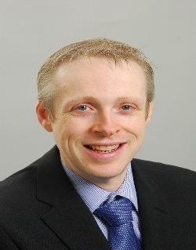
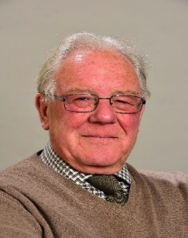

David Morton
14 Naworth Drive
Lowry Hill
Carlisle CA3 0DD

Telephone: 01228 515486
Email: david.morton@carlisle.gov.uk

Gareth Ellis
3 Etterby Scaur
Carlisle CA3 9NX

Mobile: 07984 441329
Email: gareth.ellis@carlisle.gov.uk

