APPLICATION FORM

POST APPLIED FOR |  |  |  |  |  |  |  |  | VACANCY REFERENCE
Internal Candidate |  | Yes/No |  | External Candidate | Yes/No |  |  |  | Where did you first see this vacancy advertised?

1. PERSONAL DETAILS
Title |  |  |  | Surname |  |  |  |  |  |  |  |  | First name(s)
Preferred first name |  |  |  |  | Mobile phone no.
Address (including postcode)
Email (application updates will be sent to the email address provided)
National Insurance Number

2. REHABILITATION OF OFFENDERS
Do you have any convictions or cautions (excluding youth cautions, reprimands or warnings) that are not ‘protected’ as defined by the Ministry of Justice?
Yes / No - If “Yes”, please describe the offence and date of conviction
The amendments to the Rehabilitation of Offenders Act 1974 (Exceptions) Order 1975 (2013 and 2020) provides that when applying for certain jobs and activities, certain convictions and cautions are considered ‘protected’. This means that they do not need to be disclosed to employers, and if they are disclosed, employers cannot take them into account.
Guidance about whether a conviction or caution should be disclosed can be found on the Ministry of Justice website.

3. RELATIONSHIPS
Are you related to any Councillor or Officer of this Council? If yes, please give details (e.g., name, position held, and relationship). Please note that Canvassing of Councillors or Senior Officers shall lead to disqualification.
Yes / No – Details:
Have you previously been employed by Carlisle City Council? |  |  |  |  |  |  |  |  |  | Yes / No
Carlisle City Council is a proud supporter of the Armed Forces Covenant. Have you served in any of the British Armed Forces? |  |  |  |  |  |  |  |  |  | Yes / No
Are you the partner of someone who is relocating to join North Cumbria Integrated Care in one of their hard to fill posts? Please see https://www.ncic.nhs.uk/careers/help-relocate for further information. |  |  |  |  |  |  |  |  |  | Yes / No – if “Yes” please give details

4. RIGHT TO WORK IN THE UK
Are there any restrictions to your residence in the UK that might affect your right to take up employment? |  |  |  |  |  |  | Yes / No - If “Yes” please give details
Do you need a work permit to work in the UK? |  |  |  |  |  |  | Yes / No

5. REFERENCES
Please give two referees who can comment on your professionalism / work ability, one of whom should be your present / most recent employer.
Do you explicitly consent to us contacting referees after you have been conditionally offered a post and have verbally accepted the position? |  |  |  |  |  |  |  | Yes / No
You should be aware that as part of Carlisle City Council’s Anti-Fraud Strategy, any offer of employment within the Revenues and Benefits Services Unit is subject to receipt of satisfactory references for the last five years of employment.
Reference 1 |  |  |  |  | Reference 2
Name & Title |  |  |  |  | Name & Title
Job title |  |  |  |  | Job title
Organisation |  |  |  |  | Organisation
Address |  |  |  |  | Address
Email |  |  |  |  | Email
POST APPLIED FOR |  |  |  |  |  |  |  |  |  |  |  | VACANCY REFERENCE

6. EDUCATION
School |  |  |  |  |  | Qualifications Gained
Do you hold a driving licence?  Please provide further details if this is required for the position. |  |  |  |  |  | Yes / No

7. PROFESSIONAL QUALIFICATIONS / MEMBERSHIP OF PROFESSIONAL BODIES
Full Details of Professional Qualifications and the date you achieved them. We encourage you to include all of your qualifications (for example they may not be work related – First Aider, Holiday Spanish, Run Leader)
Qualification
Date Studied |  |  |  |  |  |  |  |  |  |  |  | Where studied
Qualification
Date Studied |  |  |  |  |  |  |  |  |  |  |  | Where studied
Qualification
Date Studied |  |  |  |  |  |  |  |  |  |  |  | Where studied
Qualification
Date Studied |  |  |  |  |  |  |  |  |  |  |  | Where studied
Qualification
Date Studied |  |  |  |  |  |  |  |  |  |  |  | Where studied

8. CURRENT EMPLOYMENT
Are you currently Employed ☐ or Unemployed ☐ (if unemployed give details of last employment below)
Name of employer
Address
Job title
Date Appointed |  |  |  |  |  |  |  |  |  |  |  | Date Terminated
Latest Salary/Scale |  |  |  |  |  |  |  |  |  |  |  | Length of notice
Summary of main duties / purpose of job. Please also include your key achievements.

9. PREVIOUS EMPLOYMENT

Starting with the most recent, please cover the last 10 years including any gaps. Continue a separate sheet if necessary.
Name of employer
Job Title
Final salary/Scale
Reason for leaving
Period of Employment | Month and Year: | To | Month and Year:
Name of employer
Job Title
Final salary/Scale
Reason for leaving
Period of Employment | Month and Year: | To | Month and Year:
Name of employer
Job Title
Final salary/Scale
Reason for leaving
Period of Employment | Month and Year: | To | Month and Year:
Name of employer
Job Title
Final salary/Scale
Reason for leaving
Period of Employment | Month and Year: | To | Month and Year:
Name of employer
Job Title
Final salary/Scale
Reason for leaving
Period of Employment | Month and Year: | To | Month and Year:
Name of employer
Job Title
Final salary/Scale
Reason for leaving
Period of Employment | Month and Year: | To | Month and Year:
Name of employer
Job Title
Final salary/Scale
Reason for leaving
Period of Employment | Month and Year: | To | Month and Year:

10. REASONS FOR APPLYING
Please explain why you are applying for this post - you may wish to consider the Council’s Values which are Clear, Committed and Confident.
Carlisle City Council offers all employees three days special leave per year to undertake voluntary work. If you had the opportunity, what would you do and how would this benefit yourself and the local community?

11. RELEVANT EXPERIENCE / SKILLS
Please give details of any achievements, career plans or particular areas of work experience (including voluntary work), which you feel are most relevant to this post. Continue on a separate sheet if necessary.

12. INTERESTS / LEISURE ACTIVITIES

13. GDPR
The Council of the City of Carlisle complies with the General Data Protection Regulation (EU) 2016/679 and the Data Protection Act 2018. The information provided will be held securely for the purpose of administering your application and any subsequent work. Your personal information will not be used for any other purpose but may be shared with third parties if the post applied for is externally funded and the funding body is active in the recruitment process. Applicants are required to read the Council’s Job Application Privacy Notice, which is available at www.carlisle.gov.uk or on request.

14. DECLARATION
I declare to the best of my knowledge the information on this application is true and accurate. I understand that any false statements or failure to disclose any information requested on this form may result in my application being disqualified. Discovery after appointment may lead to dismissal without notice or disciplinary action.

I have read the Council’s Privacy Notice and understand how and why my information will be processed for the purpose of the recruitment process, and I understand my rights associated with the Council processing my personal data.
Signed |  | Date
Please note that if application is sent by email you will be required to sign form if selected for interview.
This authority is under a duty to protect the public funds it administers, and to this end may use the information you have provided on this form for the prevention and detection of fraud. It may also share this information with other bodies responsible for auditing or administering public funds for these purposes.

Completed application forms should be returned via email to vacancies@carlisle.gov.uk or alternatively by post to:
Vacancies, HR & Payroll Team, Carlisle City Council, Civic Centre, Carlisle CA3 8QG
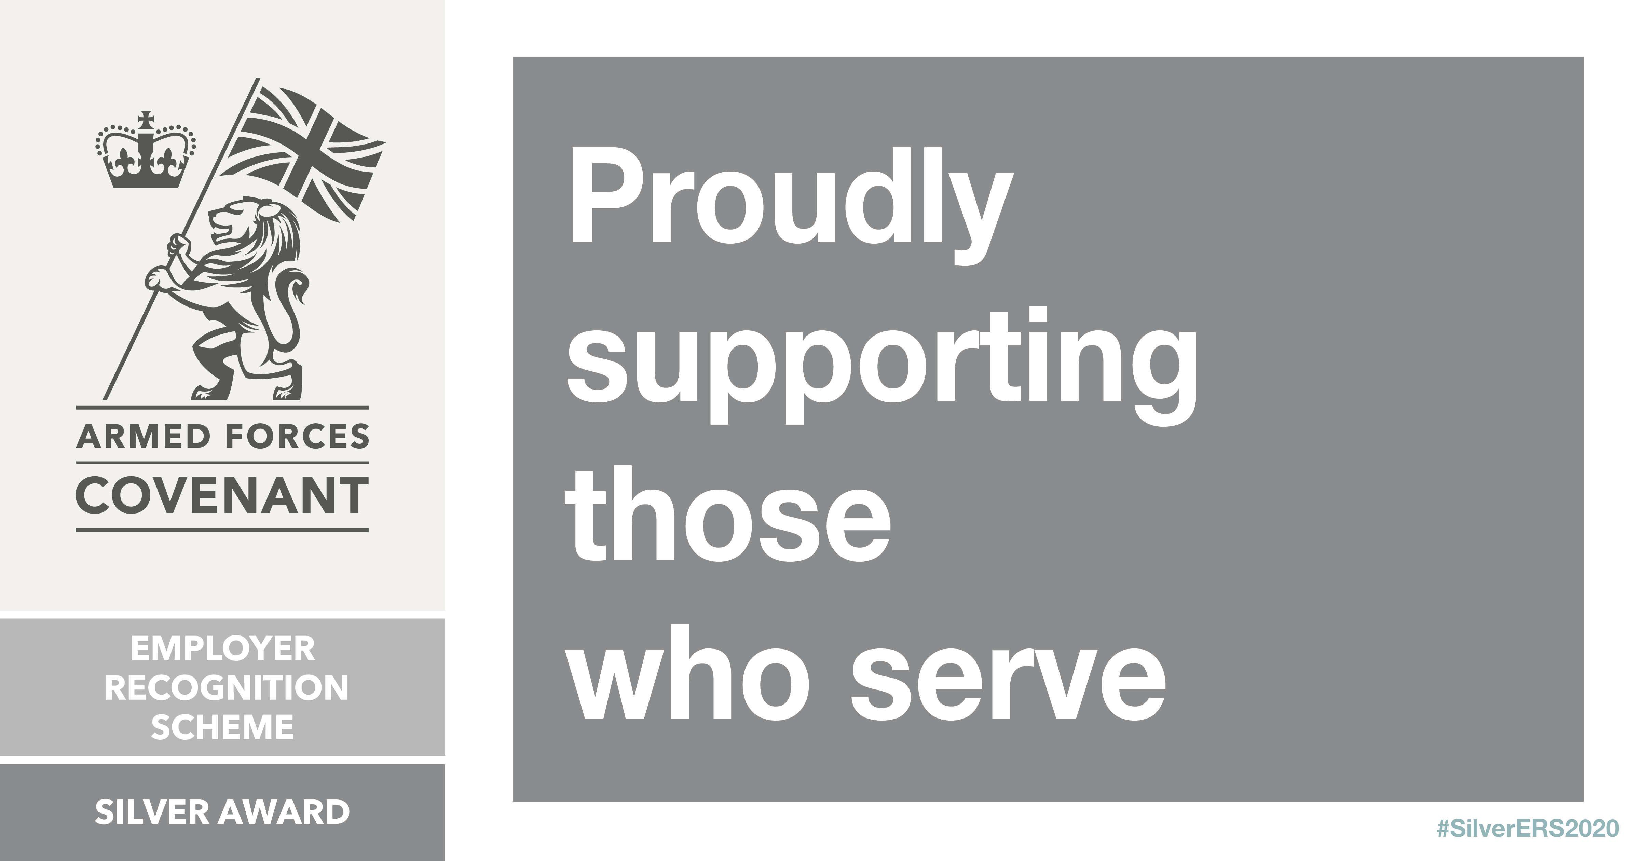
DIVERSITY MONITORING

At Carlisle City Council we monitor our recruitment processes to ensure that all applicants are fairly assessed and that we meet our obligations under the various Acts of Parliament and related Codes of Practice concerned equality. Please help us to carry out this monitoring by answering the questions below. They are placed on a separate page to the application form to emphasise that they relate only to monitoring
EQUAL OPPORTUNITIES MONITORING

This page will be detached and will not form part of the selection procedure. Data will be used for statistical purposes, and if successful will be held on your personal record. Please tick appropriate boxes.

Full Name:

National Insurance Number
Sex
 | ☐ | Male | ☐ | Female | ☐ Non-binary | ☐ Other | ☐ Prefer not to say
Gender Is your gender identity the same as the gender you were assigned at birth?
 | ☐ | Yes | ☐ | No | ☐ | Prefer not to say
Preferred Title
 | ☐ | Mr | ☐ | Mrs | ☐ | Miss | ☐ | Ms | ☐ | Other – please specify
Relationship Status
 | ☐ | Married | ☐ | Single | ☐ | Separated | ☐ Divorced
 | ☐ | Civil Partnership | ☐ | Co-habiting | ☐ | Widowed | ☐ Prefer not to say
Ethnic Origin (Please tick the box that you feel best describes your ethnic origin)
 |  | White: |  |  |  | Asian/Asian British:
 | ☐ | British (English, N Irish, Scottish, Welsh) |  |  | ☐ | Indian
 | ☐ | Irish |  |  | ☐ | Pakistani
 | ☐ | Gypsy or Irish Traveller |  |  | ☐ | Bangladeshi
 | ☐ | Any other white background (please specify) |  |  | ☐ | Chinese
 |  |  |  |  | ☐ | Any other Asian background (please specify)
 |  | Mixed/Dual Heritage:
 | ☐ | White & Black Caribbean |  |  |  | Black/Black British:
 | ☐ | White & Black African |  |  | ☐ | Caribbean
 | ☐ | White & Asian |  |  | ☐ | African
 | ☐ | Other mixed background (please specify) |  |  | ☐ | Any other black background (please specify)
 | ☐ | Prefer not to say
Nationality:
Disability Do you consider yourself to have a disability/impairment under the Equality Act 2010?
(See Note 1 overleaf)
 | ☐ | Yes | ☐ | No | ☐ | Prefer not to say
Age Range
 | ☐ | 16-24 | ☐ | 25-34 | ☐ | 35-44 | ☐ | 45-54 | ☐ | 55-64 | ☐ 65+
 | Date of Birth

Continued on next page
Faith/Religious Belief
 | ☐ | Christianity | ☐ | Buddhism | ☐ | Hinduism
 | ☐ | Judaism | ☐ | Islam | ☐ | Sikhism
 | ☐ | No religion | ☐ | Other religion | ☐ | Prefer not to say
Sexual Orientation
 | ☐ | Heterosexual | ☐ | Gay or lesbian | ☐ | Bisexual
 | ☐ | Other | ☐ | Prefer not to say

NOTE 1: Criteria for classification as disabled under the Disability Discrimination Act

Equality Act 2010 defines that a person has a physical or mental disability/impairment if it has a substantial and long-term adverse effect on his / her ability to carry out normal day to day activities.

Long term is usually defined as a year or longer.

Impairment may affect:

- mobility;

- manual dexterity;

- continence;

- ability to lift, carry or otherwise move everyday objects;

- memory or ability to concentrate, learn or understand; or

- perception of the risk of physical danger.

- speech, hearing or eyesight (but see below)

(If a person’s sight is corrected by wearing spectacles or contact lenses, this is not regarded as a disability.)

These notes are for guidance only.

--------------------------------------------------------------------------------------------------------------------------------------

NOTE 2: Data Protection

The information you supply on the application form will be used to assess your suitability for the post applied for (or another relevant post). These details will only be disclosed to those persons involved in the selection process or HR & Payroll administration.

Carlisle City Council will retain the forms of unsuccessful applicants for 6 months – in accordance with current guidance.

Should you be successful, certain details from this form may be checked, and data matched to help prevent fraud. Some of the information will be entered into the Personnel Computer System, which will allow Carlisle City Council to administer your employment. This form will then be placed into your Personnel file and retained until after you complete your employment with Carlisle City Council – for as long as legislation dictates.

Please be assured that Carlisle City Council will protect your information and treat as confidential at all times.

