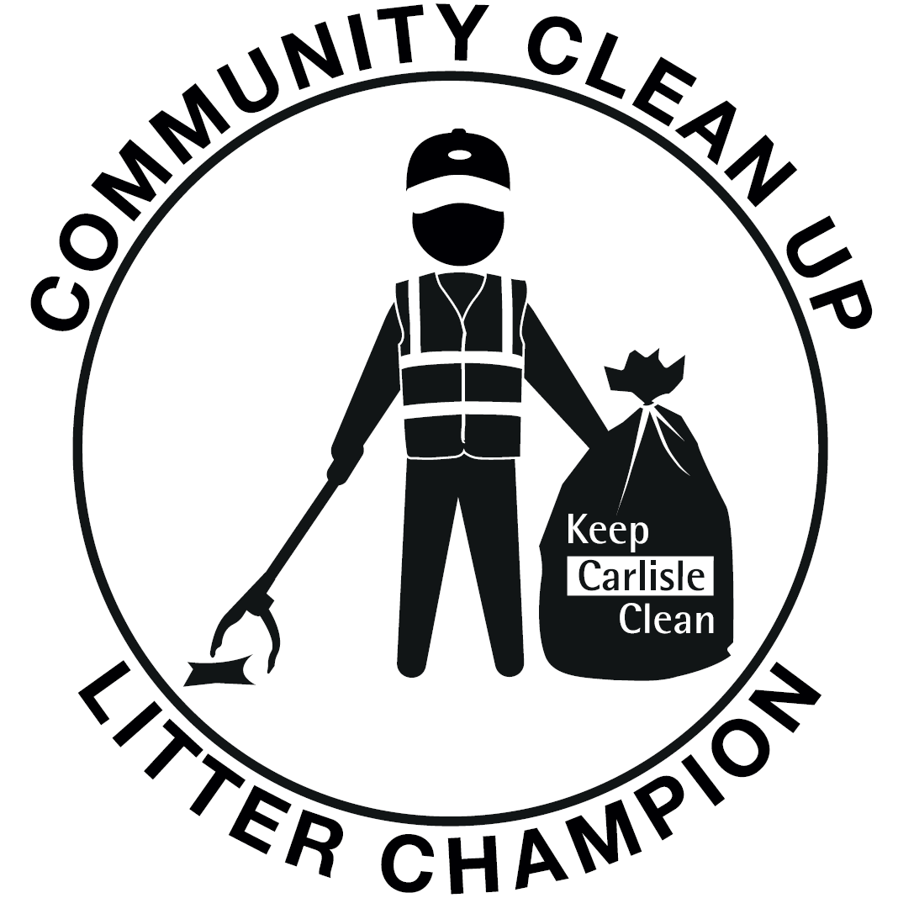

Thank you for joining our litter champion scheme and helping us make a difference to our community.
By signing up we will provide you with:
- a litter picker, hi-vis vest, gloves, strong black bags for non-recyclable litter and purple bags for recycling mixed glass, cans and plastics (all together) all contained within a small wheelie bin for storage.
In return all we ask is:
- You keep in contact with our office when you have an event planned, preferably by emailing wasteos@carlisle.gov.uk (or calling 01228 817472 or 817363) and let us know where the litter picked waste has been left for collection.

- You send us any pictures of the great work you have been doing to wasteos@carlisle.gov.uk

- You fill out our ‘Litter Registration Form’ (attached) and support Carlisle City Council to help improve our local area.

- You follow our health and safety guidelines provided in our do’s and don’ts list and on the risk assessment sheets (attached).

Safety do’s and don’ts List

DO:
- Always wear the hi-vis and gloves provided

- Wear strong boots or shoes

- Wash your hands after litter picking

- Make sure a responsible adult is supervising children taking part in the litter pick

- Carry a mobile phone (if you have one) and always let your family/friends know where you are going and when you are expected home

- Stay on public land and don’t stray off the path

DON’T:
- Pick up or handle any needles or sharp objects*

- Pick up any dog mess*

- Lift anything that is too heavy

- Work on or near any busy roads

- Work when it is dark or unsafe

* If you come across any of these items please report them to wasteos@carlisle.gov.uk

Litter Champion
Registration Form

Thank you for volunteering to be a Litter Champion. Please complete this form below (if you are under 16, please ask your parent or guardian to complete on your behalf).
Name
(including group name if applies):

Address:
Postcode:
Date of Birth (if under 16):
Home phone number:
Mobile phone number:
Email address:

Carlisle City Council will provide you with:
Items | Quantity Required
Litter Pickers
Hi-Vis Vests (Childs, Small, Medium, Large, XL)
Gloves
Litter picking hoops (to hold bags)
Black bags (for non-recyclable waste)
Purple bags (for glass, cans & plastics only).
Please advise us when you require more bags by emailing wasteos@carlisle.gov.uk

I give my permission for photographs to be used for publicity (please tick)

Please note all items remain the property of Carlisle City Council

Signed……………………………………………................Date……………………………….
PRINT……………………………………………………………………………………………...

LITTER PICKING SAFETY SHEET

LITTER PICK LOCATION: (area) DATE:

The safe procedure for litter picking and lifting, ensuring the safety of both the volunteers and members of the public at all times. From the 19th July, most of the legal restrictions have now ended or eased. However, we encourage all volunteers to continue to protect yourselves and your community. Please continue to monitor the guidance and any local restrictions that may come into force. This guidance may be superseded by any subsequent changes in the government legislation. If you have any coronavirus symptoms or have been in contact with anyone who has had symptoms please follow government guidelines, stay at home, and don’t undertake any volunteering activity.

HAZARDS | SPECIAL PRECAUTIONS OR EQUIPMENT | PERSONAL PROTECTIVE EQUIPMENT
- Close contact with members of the public.  - Cross contamination from discarded masks, etc.  - Injury form using tools incorrectly.  - Injury from sharps and needles.  - Strains / sprains from poor lifting techniques.  - Strains from over stretching.  - Slips and trips.  - Illness caused by bad weather conditions or hot weather.  - Injury caused by vehicles.  - Ingestion of dog foul.  - Injury to eyes/face if reaching into bushes. | - Avoid physical contact; being close & face-to-face and shouting.  - Face covering if meeting indoors or sharing vehicles.  - Continuously aware of people working in surrounding area, both other volunteers and members of public.  - Continue to maintain social distancing with anyone you do not live with.  - Participants to wear gloves and use litter pickers at all times.  - Do not share equipment.  - Use hand sanitiser  - No needles to be picked up.  - Wheelbarrows to be used to move big items around site. Large items to be lifted in teams. | - Safe footwear.  - Hand protection.  - Wet weather/bad weather gear, sun cream and water.  - Litter pickers.  - Hand washing facilities/hand wipes/hand sanitiser.  - Face coverings.
 | PERMIT TO WORK REQUIRED?
 | NO

WORK METHOD
- Individuals currently shielding, in ‘at risk’ groups or displaying symptoms (or in contact with those with symptoms) or have been directly advised to self-isolate should not litter-pick.
- Wash hands before and after, at home or nearby w/c facility. Wash your hands regularly and for 20 seconds.
- Frequent use of hand sanitiser and avoid touching face.
- Wear a face covering in indoor settings. When outdoors stay at least 1 metre from fellow volunteers and members of the public.
- Stay at least one metre from members of the public.
- Litter pickers should be sanitised before and after use.
- Ensure that correct procedures are used when moving and lifting rubbish. Use good lifting techniques and be aware of other people around you at all times.
- If you find a needle or sharp object, do not touch it, report it to the Neighbourhood Services Team at Carlisle City Council (01228 817472) to arrange collection.
- Ensure that you have adequate space around you when using tools.
- Plan system of work before starting.
- Ensure that all tools are used correctly and that any damaged equipment is reported to the group leader/Carlisle City Council.
- Wear safety boots/wellies, which will protect your feet from injury.
- Wear gloves at all times when working with tools.
- Keep work areas as clear as practicable
- Ensure that rubbish and tools are not left lying in the path, which can be a trip hazard
- Stop work to let a member of public past.
- Ensure correct lifting techniques are used when moving and lifting rubbish.
- Stay out of the way of vehicles when in use.
- Never leave tools unattended.
- In instances of bad weather wear suitable waterproof/windproof clothing, and in extreme conditions consider whether to go ahead
- Ensure first aider, first aid kit and mobile phone (check for signal) on site at all times.

ACKNOWLEDGEMENT

I the undersigned have read, understood and will abide by the contents of this Safety Sheet.

NAME (PRINT) | SIGNATURE | DATE

Please return this sheet to Carlisle City Council, Neighbourhood Services, Civic Centre, Rickergate, Carlisle, CA3 8QG or email wasteos@carlisle.gov.uk , along with the completed registration form. Thank you.

