Catering Premises To Let
Unit 33, Carlisle Enterprise Centre
James Street, Carlisle, CA2 5BB
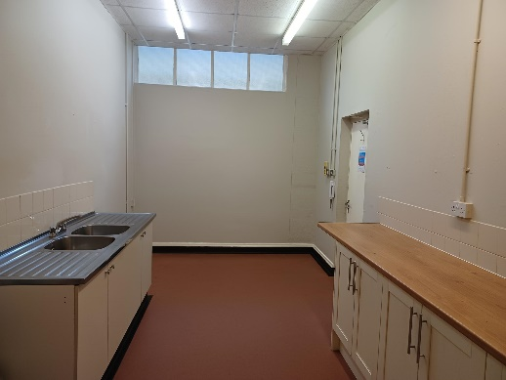
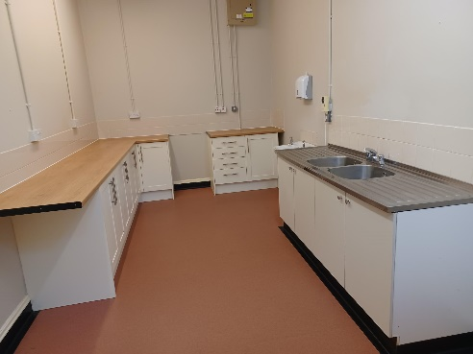
Ideally situated close to Carlisle city centre, in close proximity to railway station and city centre amenities
Small catering unit. Situated on first floor.
Gross internal Area of 46 sqm
Available utilities include internal/communal water, and electricity supply
Free car parking and central post box
Flexible access with communal W.C., welfare facilities and meeting rooms
CCTV

Competitively priced at £165 (excl VAT) per month inclusive of all service charges (excluding utilities)
CONTACT: 01228 817212 or enterprisecentre@carlisle.gov.uk for further details or to arrange a viewing

